

**skills bootcamp learner**

Data Analysis with SQL and PowerBI

Academic Report on Jameson High School

March 18, 2024

chinenye_faith_umego@learners.purplebeard.co.uk

# Presented by

# **Chinenye Faith Umego**



# **Introduction**

This report presents the analysis on student performance data from Jameson High School. The analysis aims to understand various factors affecting student performance, identify patterns, outliers, and provide insights to that can enhance Jameson High students’ academic performance.

## Data Overview

The data comprises of five tables; StudentAttendance, Students, Subjects, StudentScores and Teachers, and these tables have over 50 records. Firstly the Jameson. bak file was restored using the MS SQL Server Management Studio within the MS Server environment. The data was then imported into PowerBI environment where it was transformed and analyzed across key questions.

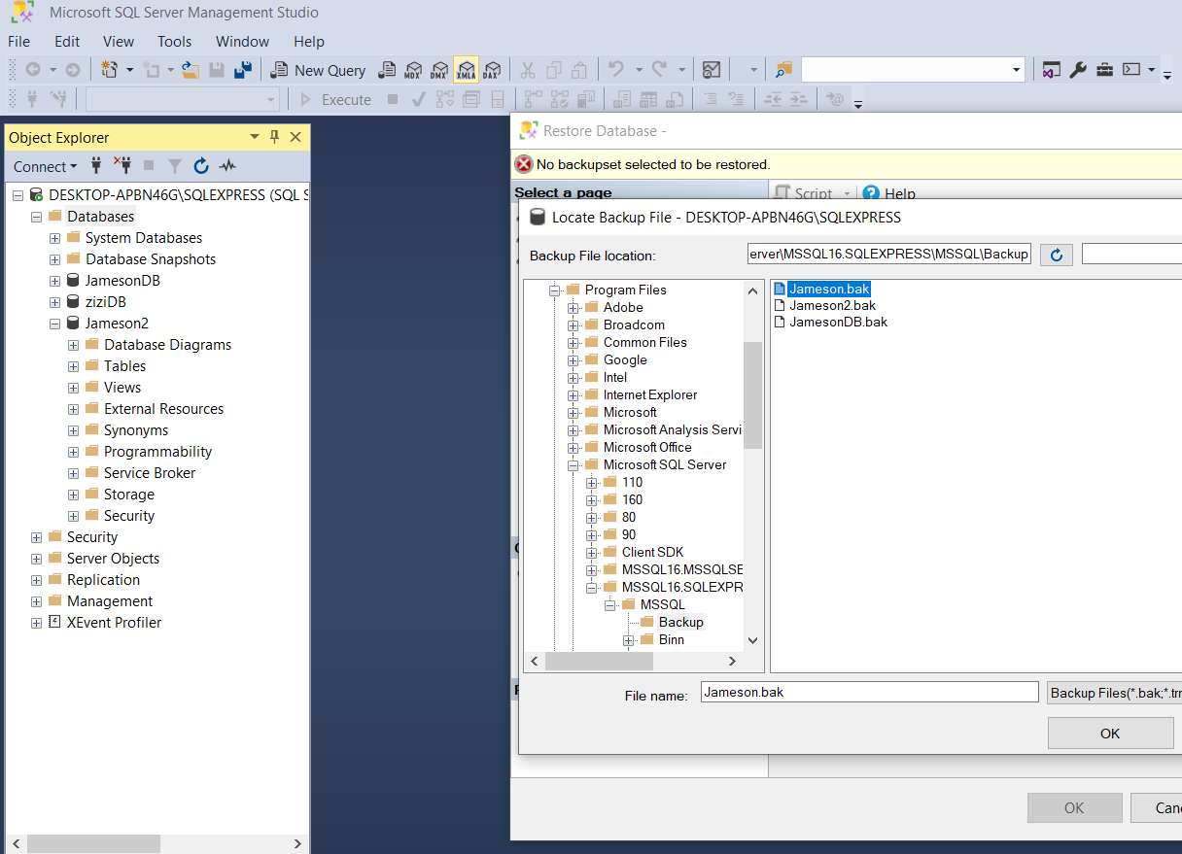

Fig 1.0 MS SQL Server – Data restoration

The .bak file was imported into the MS SQL server with using the respective instance and server name; DESKTOP-APBN46G\SQLEXPRESS and SQLEXPRESS

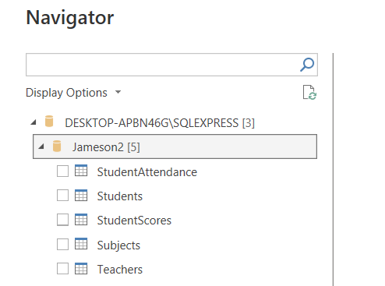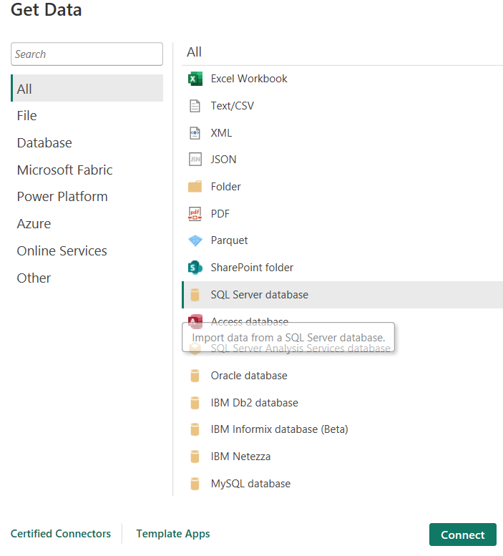

Fig 1.1 Get Data - Connecting to MS SQL Server

# Data Visualization

## Jameson High School Academic Performance Dashboard

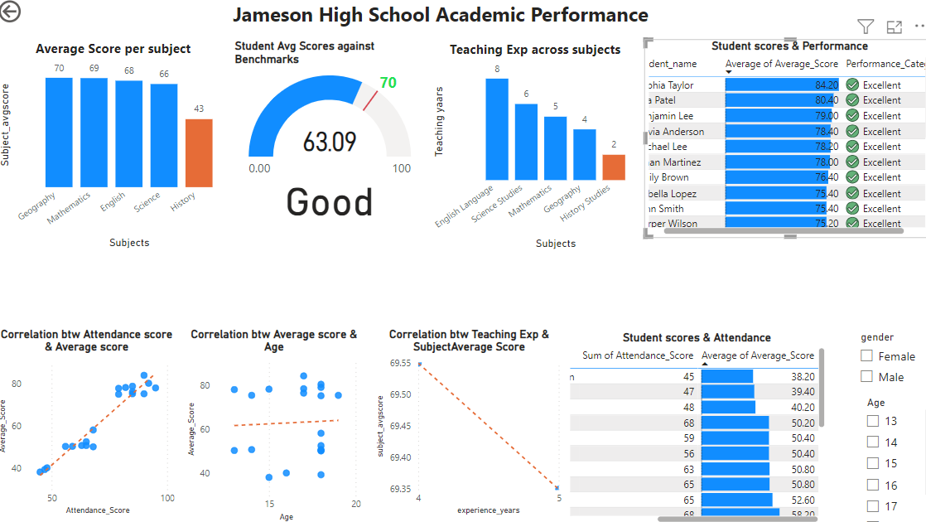

In order to investigate students performances across the given factors such as ; DOB, Gender, Subjects, Teacher’s Experience, Performance category and Performance scores, different visuals such as bar and column charts, color codes, gauge, table, slicers and scatterplot was employed to build an interactive dashboard. All the factors given were set as continuous variables except Age and Gender which was set at categorical.

The measure “Performance category” is used to rate the average student scores against the benchmarks; education board target and maximum target. Other measures such as subject total score and subject average score was also calculated and applied to the table and bar chart visuals. Age was derived from the date of birth and used in the chart and filter within the page. Both benchmarks was made to be measures and used in the gauge visual as target and maximum score. This is the link to view the dashboard on PowerBI Service.

The next section presents the finding for this analysis.

## Findings

1. From the table below, it is shown that half of the students meet the education board target scoring above 70% mark. Three student score very low below 40%.

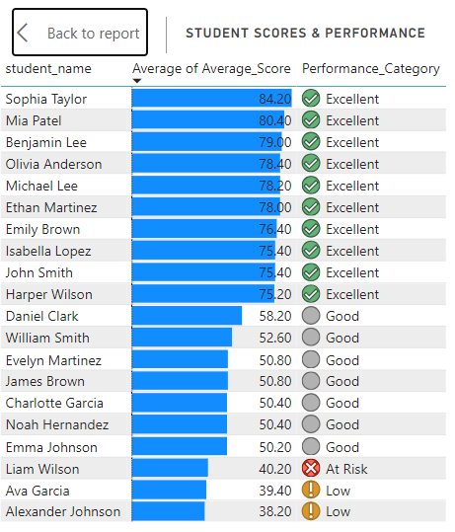

1. The students performed similarly above 60% across three subjects (Geography, Mathematics, English and Science). While students performed well in Geography at 63.55, they also performed poorly in History at 43.25.

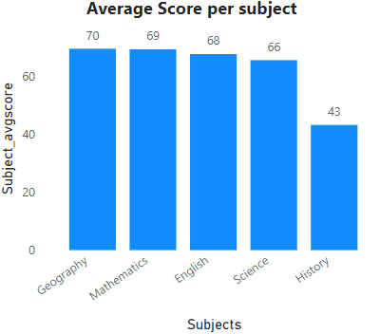

Fig 2.1 Distribution of student performance across subjects

The overall average performance of students across subjects is 63.09, which is close to the education board benchmark, 70%

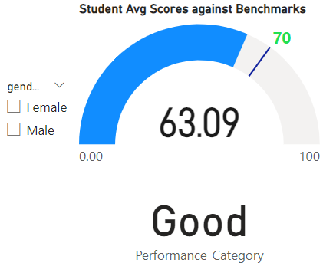

Fig 2.2 Overall school performance against Education Board target (70) and Maximum target (100%)

At 66.08 and 60.10 respectively, both female and male students did not surpassed the education benchmark. It can also be observed that students who surpassed the education board target comprised of 6 females and 4 males. The topmost student is Sophia Taylor while the least performing student is Alexander Johnson. In the bottom 5 category, two students tied at 50.40.

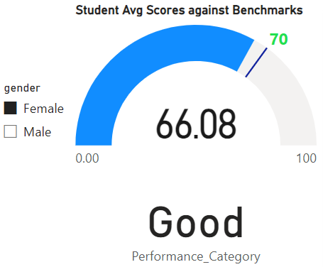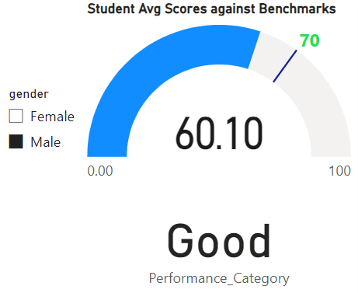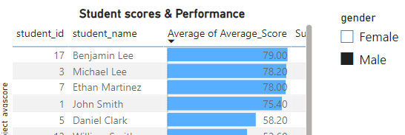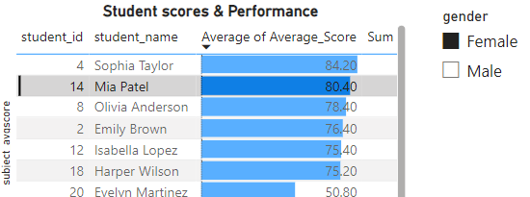

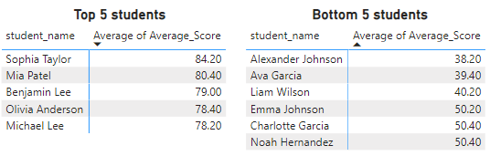

Fig 2.3 School performances based on Gender and top and bottom students

1. The Age variable was set to categorical and the average line is used here to show the central of tendency of the average score across the ages. It can be observed below (Fig 2.4) that the data points are scattered sparely around the average line, this implies that there is no relationship between both variables.

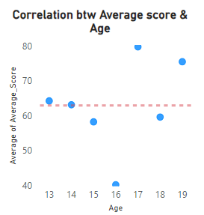

Fig 2.4 Correlation between student average performance and students’ age

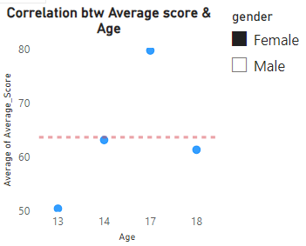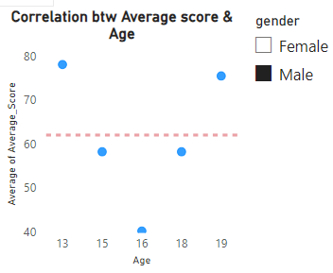

Fig 2.5 Correlation between student average performance and students’ age across gender

1. It can be observed that the subject History has the least experienced teacher compared with other subjects. In addition, top performing subjects also had teachers with more experience.

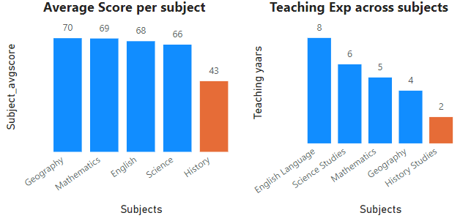

Fig 2.6 Distribution of Student performance score and teachers’ experience across subjects

1. In Fig 2.7 below, it can be seen that there is a negative correlation implying that there is a likelihood students still perform better in some subjects where teachers have less experience. However, it will be recommended to use larger datasets to investigate further because the data points is not enough to confirm.

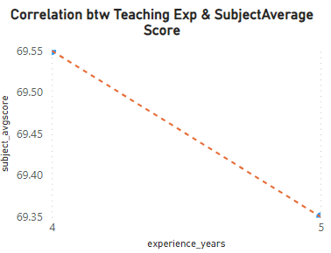

Fig 2.7 Correlation between teachers’ experience and subject performance

1. The students with low performance scores also have low attendance scores for respective subject.

The correlation graph show a strong positive correlation between performance score and attendance score.

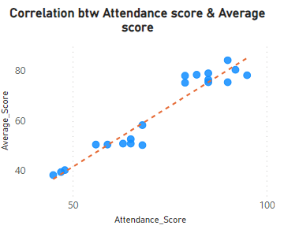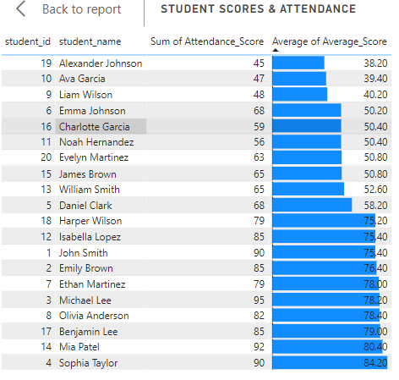

Fig 2.8 Correlation between students’ performance and attendance

Recommendations

Based on the analysis and findings above, the following are recommended;

1. The school has to implement intervention targeting students with low average performance scores and attendance scores.
2. The school has to provide support to enable students with low performance scores improve in their subjects. It is important that teachers have the required experience to inspired and improve the students’ performance in the subjects.
3. The school has to work with parents to improve class attendances and reduce students’ truancy.
4. The school administrator has to ensure that the history teacher improves their teaching methods in the class or otherwise, hire a more experienced History Teacher or substitute teacher.